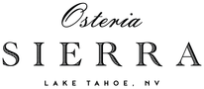

Hyatt Regency - Osteria Sierra

Cocktails

|  |  |
| --- | --- |
| Aperol Spritz | 18 Glass |
| Espresso Martini | 25 Glass |
| Negroni Sbagliato | 20 Glass |
| Old Fashioned | 25 Glass |
| Manhattan | 25 Glass |
| Cosmo | 21 Glass |
| Parola Scorsa | 23 Glass |